Emtech ZM-2 Z match antenna tuner and tuning indicator
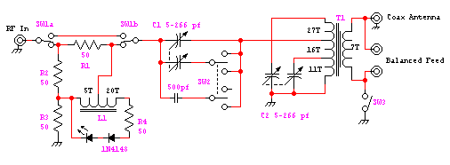
Components
- L1 - 25 turns of 28 gage enamel wire on a FT37-43 toroid core. 5 turns <tap> 20 turns The 5 turns are on the left side as you look at the schematic feeding R2, R3 & the LED. The 20 turns are on the right feeding R4.
- T1 - (more info to follow)
- C1, C2 Dual poly tuning caps, 5-266 pf each section

